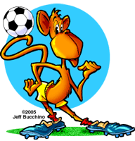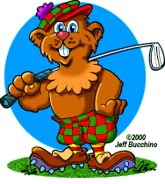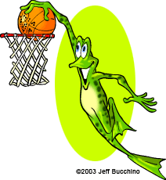

How many ball sports do you know?

Work in a group.

**Explain the rules of one sport.**

* What’s your favourite sport?
* How often do you play it?
* When was the last time you played it?
* Do you prefer team sports or individual sports?
* Do you think sports are important? Why (not)?
* …

**Interview a friend; report to the class.**

Why practising sports is good for you:

* Your parents will stop nagging you.
* …………………………………………………………………………………………………………………
* …………………………………………………………………………………………………………………
* …………………………………………………………………………………………………………………
* …………………………………………………………………………………………………………………
* …………………………………………………………………………………………………………………
* …………………………………………………………………………………………………………………

Why I like sports

Questions for Gopher about his father:

* (sports/father/like) What sports does your father like?
* (prefer/watching/playing) ………………………………………………………………
* (where) …………………………………………………………………………………………………
* (how often) …………………………………………………………………………………………
* (when) ……………………………………………………………………………………………………

I’m Gopher and I love sports. My favourite sport is baseball. I play it twice a week with my friends from school. My dad taught me a lot about baseball. We used to practice in our garden at home. I once broke our kitchen window and mum wasn’t too happy. Nowadays my dad has become quite lazy and it’s hard to get him off the couch.

Read the text.

Have you ever had an accident while playing sports? Tell the class.

Gopher’s younger brother Max is into golf. He’d like to become the new Tiger Woods, so he has already started cheating on his girlfriend. Unfortunately, his golf game hasn’t improved much yet.

Give him some tips to get better:

* Buy better golf balls.
* ………………………………………………………………………
* ………………………………………………………………………
* ………………………………………………………………………
* ………………………………………………………………………
* Football (AmE soccer)
* American football
* …………………………………………………………………
* …………………………………………………………………
* …………………………………………………………………
* …………………………………………………………………
* …………………………………………………………………
* …………………………………………………………………
* …………………………………………………………………
* …………………………………………………………………
* …………………………………………………………………
* …………………………………………………………………
* …………………………………………………………………